**ISBM COLLEGE OF ENGINEERING, PUNE**

**(Affiliated To Savitribai Phule Pune University)**



**A PROJECT REPORT**

**ON**

**“BLOCKCHAIN-BASED VOTING SYSTEM”**

**SUBMITTED BY :**

**Pranjal Santosh Londhe - 31**

**UNDER THE GUIDANCE OF :**

**Prof. Sangeeta Alagi**

**SUBMITTED TO :**

**Department Of Artificial Intelligence & Machine Learning, ISBM College Of Engineering, Pune**

**(Academic Year: 2024-25)**

# ISBM COLLEGE OF ENGINEERING, PUNE

**(Affiliated To Savitribai Phule Pune University)**



**CERTIFICATE**

**This is to certify that**

**Pranjal Santosh Londhe -31**

of class Third Year Engineering (2024-2025) have successfully completed the Project on

**“BLOCKCHAIN-BASED VOTING SYSTEM”** under the guidance of **“PROF. SANGEETA ALAGI”** in the requirement for the award of Third Year Engineering from ISBM College Of Engineering, Pune.

.………………………… ..….………………….. ………………………..

**Prof. Sangeeta Alagi Prof. Kirti Randhe Dr. P. K. Srivastava**

**(Project Guide ) ( H.O.D ) (Principal)**

This Project Report has been examined by us as per the **Savitribai Phule Pune University, Pune** requirements at **ISBM College of Engineering, Nande, Pune on 2024-2025.**

….………………….. ………………………..

**Internal Examiner External Examiner**

**ACKNOWLEDGEMENT**

The completion of any project could have been possible with continued & dedicated efforts & guidance of large number of faculty & staff members of the institute. We acknowledge our gratitude to all of them. The acknowledgement however will be incomplete without specific mention as follows.

First and foremost, we wish to record our sincere gratitude to the Management of this college and to our Respected Principal **Dr. P. K. SRIVASTAVA**, for his constant support and encouragement in the preparation of this report and for the availability of library facilities needed to prepare this report.

We wish to acknowledge our deep gratitude to  **PROF. SANGEETA ALAGI,** lecturer at **ISBM COLLEGE OF ENGINEERING** for his cooperation and guidance. We would also like to acknowledge with much appreciation the crucial role of our **H.O.D** **PROF. KIRTI RANDHE** for this encouragement & providing all the facilities in the department.

We wish to thank our parents for financing our studies and helping us throughout our life for achieving perfection and excellence. Their personal help in making this report and project worth presentation is gratefully acknowledged. Last but not the least we thank the Almighty for continuous strength we were bestowed for completion of this project.

**THANK YOU….!!!**

**ABSTRACT**

The integrity of modern democratic systems is often challenged by concerns surrounding vote tampering, voter anonymity, and system transparency. This project addresses these challenges by proposing a Blockchain-based Voting System that leverages the decentralized, secure nature of blockchain technology along with advanced cryptographic methods. The core of the system is a tamper-resistant, decentralized ledger where votes are recorded as immutable transactions, ensuring transparency and reliability throughout the voting process. Voter authentication is fortified using multi-factor authentication (MFA) and cryptographic techniques, ensuring that only eligible voters can participate.

To safeguard voter privacy, the system employs privacy-preserving methods such as ring signatures, which ensure that while votes are recorded on the blockchain, the voter's identity remains anonymous. End-to-end encryption protects all communications, ensuring that votes are securely transmitted and stored. Smart contracts further automate critical election processes, including secure vote tallying and the announcement of results, enhancing both efficiency and security.

To maintain the system's integrity, a secure consensus mechanism ensures that voting data is validated across decentralized nodes, protecting the system from tampering or unauthorized access. Additionally, the system includes robust tamper detection through cryptographic hashing and real-time monitoring for detecting anomalies or potential cyber-attacks such as Distributed Denial of Service (DDoS) attacks.

To ensure the confidentiality of votes until the election period ends, time-locked encryption is employed, preventing early access to voting results. Finally, the system provides a vote verification mechanism, allowing voters to confirm that their vote was accurately recorded on the blockchain, thus reinforcing trust without compromising privacy. With its combination of security, transparency, privacy, and auditability, this Blockchain-based Voting System is a step forward in enhancing trust in the democratic process.

## TABLE OF CONTENTS

|  |  |  |  |
| --- | --- | --- | --- |
| **Sr. No.** |  | **Index** | **Page No.** |
| **1.** |  | **Introduction** | **6-8** |
|  | 1.1 | Overview of Voting Systems | **6** |
|  | 1.2 | Challenges in Current Voting Systems | **6-7** |
|  | 1.3 | Importance of Cybersecurity in Voting | **7** |
|  | 1.4 | Objectives of the Blockchain-based Voting System | **8** |
| **2.** |  | **Blockchain Technology Overview** | **9-11** |
|  | 2.1 | Introduction to Blockchain Technology | **9** |
|  | 2.2 | Key Features of Blockchain | **9-10** |
|  | 2.3 | Applications of Blockchain in Voting | **10-11** |
| **3.** |  | **System Architecture** | **12-14** |
|  | 3.1 | Voter Authentication | **12** |
|  | 3.2 | Decentralized Voting Ledger | **12-13** |
|  | 3.3 | Smart Contracts for Voting | **13-14** |
| **4.** |  | **Use Case and Implementation** | **15-17** |
|  | 4.1 | Case Study of Blockchain Voting in Elections | **15-16** |
|  | 4.2 | Overview of the System Implementation | **16-17** |
| **5.** |  | **Snapshots** | **18-19** |
| **6.** |  | **Challenges and Limitations** | **20** |
| **7.** |  | **Future Prospects** | **21** |
| **8.** |  | **Conclusion** | **22** |
| **9.** |  | **References** | **23** |

### CHAPTER 1 : INTRODUCTION

**1.1 Overview of Voting Systems :**

Voting systems serve as the foundation of democratic processes, enabling citizens to participate in decision-making through elections, referendums, or policy votes. Historically, voting systems have evolved from basic paper-based methods to sophisticated electronic systems, each aiming to make voting more accessible, secure, and accurate. The traditional **paper ballot system** is one of the oldest methods, where voters cast their votes on paper and ballots are manually counted. While simple, this method has numerous issues related to human error, fraud, and the time-consuming nature of manual counting.

**Electronic Voting Machines (EVMs)** were introduced to address some of these challenges, offering faster and more accurate vote tallying. However, concerns about the security of EVMs have surfaced, as they can be vulnerable to tampering, hacking, or software malfunctions. Similarly, **online voting** platforms are increasingly used in some regions, allowing voters to cast their votes remotely through the internet. While offering convenience, online voting also introduces significant cybersecurity risks, such as hacking and denial-of-service (DDoS) attacks.

Amid these developments, blockchain technology presents a promising solution to address the shortcomings of current voting systems. By leveraging the principles of decentralization, transparency, and cryptographic security, blockchain-based voting systems aim to create a trusted, tamper-resistant voting process. This system stores votes in a distributed ledger, ensuring that each vote is secure, immutable, and auditable while maintaining voter privacy.

**1.2 Challenges in Current Voting Systems :**

Despite efforts to modernize voting systems, several significant challenges persist, undermining the reliability and fairness of elections:

1. **Voter Fraud and Tampering**: Traditional voting systems, particularly those involving paper ballots, are vulnerable to a range of fraudulent activities. These include ballot stuffing, vote buying, impersonation of voters, and tampering with vote counts. Even electronic voting machines, which reduce the risk of human error, can be compromised through hacking or malicious software manipulation, raising concerns about election integrity.
2. **Lack of Transparency**: In many voting systems, the process is opaque, making it difficult for voters and auditors to verify that votes were counted accurately. Centralized systems, where voting data is controlled by a single entity or authority, create potential points of failure and make it harder to detect or prevent manipulation. Voters are often unable to confirm that their vote was counted correctly without sacrificing the secrecy of their ballot.
3. **Limited Accessibility**: Voting in traditional physical polling stations can be difficult for people with disabilities, those living in remote areas, or those unable to travel on election day. While online voting offers a potential solution, it often lacks the necessary security infrastructure to guarantee a safe and trustworthy experience, making it vulnerable to cyberattacks.

* 1. **Importance of Cybersecurity in Voting :**

Cybersecurity plays a critical role in ensuring that the voting process is secure, transparent, and trusted by the public. As voting systems increasingly rely on digital platforms, they face new challenges related to the protection of data and the integrity of election results. **Cyber threats** such as hacking, malware, and phishing attacks can compromise the security of the system, potentially altering the outcome of an election or undermining public trust.

To counter these threats, it is essential to implement strong cybersecurity measures. These include **encryption**, **multi-factor authentication (MFA)**, and **cryptographic protocols** to ensure the confidentiality, integrity, and availability of voting data. Encryption ensures that all communications between voters and the voting system are secure, preventing unauthorized access or tampering. MFA adds an extra layer of protection by requiring voters to verify their identity through multiple methods, such as a password and a biometric identifier.

Moreover, the **integrity** of votes must be ensured by preventing any unauthorized alterations to the data once it has been submitted.

* 1. **Objectives of the Blockchain-based Voting System :**

The Blockchain-based Voting System seeks to resolve the vulnerabilities of traditional and electronic voting methods by introducing a secure, decentralized, and transparent platform for conducting elections. The key objectives of this system are:

1. **Enhance Security**: Blockchain provides a decentralized and tamper-resistant ledger where each vote is stored as a unique transaction. Cryptographic techniques such as public-private key encryption and digital signatures ensure that votes cannot be altered once they have been cast, preventing vote manipulation or fraud.
2. **Ensure Transparency**: One of the main advantages of blockchain is that it allows for the creation of a fully auditable system. All transactions (votes) recorded on the blockchain are visible and traceable, ensuring that the entire election process can be independently verified without compromising the secrecy of individual votes. This fosters trust in the election process by making the counting of votes transparent and accountable.
3. **Preserve Privacy**: While blockchain is inherently transparent, it also supports privacypreserving mechanisms such as **ring signatures** or **zero-knowledge proofs**. These techniques ensure that while the vote is recorded on the blockchain, the identity of the voter remains anonymous, protecting the privacy of the electorate and ensuring that no one can link a voter to their voting choice.
4. **Increase Trust**: Public trust in elections is crucial for the stability of democratic systems. The immutable nature of blockchain ensures that voters can have full confidence in the results, knowing that their votes were counted accurately and cannot be altered. The system also allows voters to verify that their vote was successfully cast and recorded without revealing the content of the vote.

### CHAPTER 2 : BLOCKCHAIN TECHNOLOGY OVERVIEW

**2.1 Introduction to Blockchain Technology :**

**Blockchain** is a type of distributed database or ledger that is shared across a network of nodes (computers). It was first introduced in 2008 as the underlying technology for **Bitcoin**, but since then, its application has expanded well beyond cryptocurrency. Blockchain works by grouping transactions into blocks, which are then linked or "chained" together in a chronological order, creating a chain of blocks—hence the name *blockchain*. Each block contains a list of transactions, a timestamp, and a cryptographic hash of the previous block, ensuring the integrity and immutability of the data.

**How Blockchain Works**:

1. **Transaction**: A user initiates a transaction, such as a vote, a financial exchange, or any data input.
2. **Verification**: The transaction is broadcast to a network of peer-to-peer computers (nodes) where it is verified by solving a complex cryptographic puzzle (in systems like Bitcoin) or through other consensus mechanisms like **Proof of Stake (PoS)** or **Proof of Authority (PoA)**.
3. **Block Creation**: Once verified, the transaction is added to a block. This block contains the transaction data and the hash (unique identifier) of the previous block, forming a sequential chain.
4. **Validation and Consensus**: For a new block to be added to the chain, it must be validated by all nodes in the network according to a pre-defined consensus protocol (e.g., Proof of Work, Proof of Stake).
5. **Immutability**: Once a block is added to the chain, it cannot be altered without altering every subsequent block, which would require the consensus of the majority of the network, making tampering virtually impossible.

**2.2 Key Features of Blockchain :**

Blockchain has several defining features that make it suitable for secure, transparent, and decentralized applications like voting. These features include:

1. **Decentralization**: Unlike traditional databases that are controlled by a central authority (like a bank or a government body), blockchain operates in a decentralized network of nodes. Each node has a copy of the entire blockchain and participates in verifying and validating transactions. This decentralization makes blockchain systems resistant to centralized control and single points of failure. In a voting system, decentralization ensures that no single entity can manipulate or control the results.
2. **Transparency**: One of the main strengths of blockchain is its transparency. Every transaction on the blockchain is visible to all participants in the network, and once a block is added, it cannot be modified. This ensures a high level of accountability. In a voting system, all votes are recorded on a public ledger, making the voting process auditable and verifiable by independent entities.
3. **Immutability**: Blockchain’s cryptographic structure ensures that once data is added to the blockchain, it cannot be changed or deleted. Each block contains a cryptographic hash of the previous block, creating a chain of blocks that is immutable. In the context of voting, this means that once a vote is cast, it cannot be altered, ensuring the integrity of the voting process.
4. **Security**: Blockchain uses advanced cryptographic techniques such as **hashing** and **digital signatures** to secure transactions. Hashing creates a unique identifier for each block, while digital signatures verify the authenticity of transactions. Additionally, since blockchain is decentralized, it is less vulnerable to attacks like **Distributed Denial of Service (DDoS)**, as there is no single point of failure.

**2.3 Applications of Blockchain in Voting :**

Blockchain technology offers significant advantages for voting systems, particularly in addressing the challenges of security, transparency, privacy, and trust that plague traditional voting methods. Some of the key applications of blockchain in voting include:

1. **Decentralized Voting Ledger**:
   * Blockchain provides a decentralized, tamper-resistant ledger where votes are recorded as individual transactions. This ledger is maintained by a distributed network of nodes, making it impossible for a single entity to manipulate the results. Once a vote is cast, it is added to the blockchain, where it remains immutable and auditable by anyone.
2. **Voter Authentication and Identity Management**:
   * Blockchain can enhance voter authentication by securely storing voter identities and allowing for **multi-factor authentication (MFA)**. It can also support the use of **zero-knowledge proofs** to verify voter eligibility without revealing personal information. This helps prevent fraud, such as voter impersonation or double voting, while maintaining voter privacy.
3. **Smart Contracts for Vote Tallying**:
   * **Smart contracts** are self-executing contracts with predefined rules encoded within them. In a blockchain-based voting system, smart contracts can be used to automate the vote tallying process and trigger actions based on certain conditions. For example, smart contracts can automatically tally votes once the election period ends and declare results, reducing human errors and potential manipulation.
4. **Immutability of Votes**:
   * Once a vote is recorded on the blockchain, it cannot be altered. This immutability ensures that no votes are tampered with after being cast. Voters can verify their vote was successfully recorded on the blockchain, and auditors can trace all votes to ensure the election’s integrity.
5. **Transparent and Auditable Process**:
   * Blockchain’s transparency allows for an open and auditable voting process. Each vote is recorded on a public ledger, and the entire voting process can be independently verified by third parties without compromising voter privacy.

This level of transparency builds trust in the election process.

1. **Enhanced Security Against Cyberattacks**:
   * The decentralized nature of blockchain makes it resilient to cyberattacks. Unlike centralized voting systems, which can be targeted by hackers or subjected to DDoS attacks, blockchain’s distributed network ensures that even if some nodes are compromised, the integrity of the system remains intact. This is particularly crucial in preventing election interference by malicious actors.

### CHAPTER 3 : SYSTEM ARCHITECTURE

**3.1 Voter Authentication :**

1. **Identity Verification**: Before participating in an election, voters must prove their eligibility (age, citizenship, etc.). Blockchain systems can integrate with **digital identity** platforms that securely store voter information. This can be done using government-issued ID systems or decentralized identity solutions, such as **SelfSovereign Identity (SSI)**, which allows voters to control their personal data.
2. **Multi-Factor Authentication (MFA)**: To strengthen security, the system can implement MFA. This could involve multiple methods such as: o Something the voter **knows** (e.g., a password or PIN). o Something the voter **has** (e.g., a hardware token or mobile device).

o Something the voter **is** (e.g., biometrics such as fingerprint or facial recognition).

1. **Zero-Knowledge Proofs**: Privacy is essential in elections, and blockchain systems often utilize **zero-knowledge proofs** to allow voters to prove their identity or eligibility without revealing sensitive information. For instance, a voter can prove that they are eligible to vote without revealing their name or address.
2. **Digital Signatures**: Once the voter is authenticated, they generate a **digital signature** to authorize their vote. This ensures that the vote is securely associated with the voter, but remains anonymous, as only the voter can create this specific signature using their private key.

**3.2 Decentralized Voting Ledger :**

The **Decentralized Voting Ledger** is the core of the blockchain-based voting system. This ledger is a distributed, tamper-proof database that records every vote cast in the election. Unlike traditional voting systems that rely on centralized authorities to manage vote records, blockchain ensures that the voting process is transparent, secure, and immutable through decentralization.

Key components of the decentralized voting ledger:

1. **Tamper-Proof Voting Record**: Each vote is recorded as a transaction in a block, and these blocks are cryptographically linked to one another in a chain (blockchain). Once a vote is added to the blockchain, it cannot be changed or deleted, ensuring that the vote is immutable and preventing any tampering with the results.
2. **Decentralized Data Storage**: Instead of storing vote data on a central server, the blockchain distributes the ledger across a network of nodes (computers). Each node maintains a full copy of the blockchain, and all nodes participate in validating new transactions (votes). This decentralized architecture eliminates the risk of a single point of failure, as no one entity controls the voting process.
3. **Transparency and Auditability**: Since the blockchain is publicly available, any participant (or auditor) can verify that the voting process is conducted fairly. However, the use of cryptographic techniques ensures that while the vote is recorded transparently, the identity of the voter remains anonymous. The ledger can be audited at any time, providing a full record of all votes cast.
4. **Vote Casting Process**:
   * + After authentication, the voter submits their vote. o The vote is then broadcasted to the network of nodes. o Each node verifies the authenticity of the vote and whether the voter is eligible.
     + Once verified, the vote is added to the blockchain, ensuring its immutability.

The decentralized voting ledger makes the voting process highly secure and resistant to fraud, as any attempt to alter the vote would require the majority of nodes in the network to agree, which is nearly impossible due to the distributed nature of the system.

**3.3 Smart Contracts for Voting :**

**Smart Contracts** are self-executing contracts with the terms of the agreement written directly into code. In a blockchain-based voting system, smart contracts can automate several key functions in the voting process, ensuring that the election rules are enforced without human intervention.

Key roles of smart contracts in voting:

1. **Automated Vote Collection and Tallying**: Once a voter casts their vote, the smart contract automatically records the vote on the blockchain and starts tallying votes as they are added. This removes the need for manual vote counting, which can be prone to errors or manipulation. Smart contracts can be programmed to ensure that the vote tally is correct and accurate at all times.
2. **Validation of Voting Conditions**: Smart contracts can enforce specific voting rules, such as:
   * Ensuring that a voter can only vote once.
   * Validating that only eligible voters are allowed to cast a vote. o Rejecting any invalid or fraudulent votes.

For instance, if a voter tries to cast multiple votes, the smart contract can automatically prevent the additional votes from being recorded.

1. **Vote Encryption and Time-Locking**: Votes can be encrypted using cryptographic algorithms and stored securely on the blockchain. Smart contracts can also enforce a **time-lock mechanism**, meaning that votes remain hidden or encrypted until the election period ends. After the voting deadline, the smart contract can automatically reveal and tally the votes in a transparent manner.
2. **Ensuring Voter Privacy**: Smart contracts can incorporate privacy-preserving technologies like **Ring Signatures** or **Zero-Knowledge Proofs** to ensure that while the vote is counted, the identity of the voter remains hidden. This ensures that no one can link a specific vote to a voter.
3. **Triggering Election Results**: Once all votes are tallied, the smart contract can trigger the automatic release of the election results without any human intervention, ensuring that the results are made public transparently and instantly after the voting period concludes.

### CHAPTER 4 : USE CASE AND IMPLEMENTATION

**4.1 Case Study of Blockchain Voting in Elections :**

Blockchain voting has been trialed in several countries and contexts to evaluate its effectiveness in improving electoral processes. Below are some notable case studies that showcase the use of blockchain technology in real elections:

1. **West Virginia, USA (2018 Midterm Elections)** 
   * + **Background**: West Virginia became the first U.S. state to pilot a blockchain-based mobile voting platform during the 2018 midterm elections. The system was offered to a limited group of overseas military voters and their families, who often face difficulties in casting their votes due to distance or time constraints.
     + **Technology Used**: The platform, developed by **Voatz**, utilized blockchain to secure vote data and ensure that once a vote was cast, it could not be tampered with. Voters used a mobile app with **biometric authentication** (fingerprint or facial recognition) to cast their votes.
     + **Results**: The pilot was deemed a success, allowing voters to participate in the election securely and remotely. However, concerns were raised about the long-term security and scalability of mobile blockchain voting, particularly regarding potential vulnerabilities in mobile devices.
     + **Key Takeaways**: The West Virginia pilot demonstrated the potential for blockchain to make voting more accessible to remote voters while ensuring vote integrity. However, this use case also highlighted the need for robust security, particularly around voter authentication and the integrity of mobile devices.
2. **Zug, Switzerland (2018 Blockchain Voting Pilot)** 
   * + **Background**: In 2018, the Swiss city of Zug, often referred to as "Crypto Valley," conducted a blockchain-based voting trial. The aim was to test the feasibility of using blockchain for municipal referendums and elections.
     + **Technology Used**: The Zug voting platform allowed citizens to participate in a nonbinding referendum via a blockchain system. The system used **self-sovereign identities**

**(SSI)** on the blockchain, where voters controlled their own identity data. Voters were

able to cast their votes using their digital identities, which were stored securely on the blockchain.

* + - **Results**: The pilot was successful in demonstrating the potential of blockchain technology to streamline identity verification and ensure the transparency of the voting process. Citizens reported a positive experience with the system, and the city government gained valuable insights into the implementation challenges and benefits.
    - **Key Takeaways**: The Zug case study highlighted blockchain’s effectiveness in handling secure digital identities and enhancing transparency in local elections. It also showcased the potential for integrating digital identity solutions with voting systems.

**4.2 Overview of the System Implementation :**

Implementing a blockchain-based voting system involves several key steps to ensure security, transparency, and usability. Here's a summarized overview:

1. **System Setup and Requirements** o **Blockchain Platform**: Choose between public (e.g., Ethereum) or private blockchains (e.g., Hyperledger) based on decentralization needs.

* + - * **Smart Contracts**: Develop smart contracts for automated vote casting, tallying, and results publishing.
      * **Consensus Mechanism**: Select an appropriate mechanism (e.g., Proof of Stake) to validate votes securely and efficiently.

2. **Voter Registration and Authentication** o **Identity Management**: Implement Self-Sovereign Identity (SSI) to ensure voters control their identities and meet eligibility.

* + - * **Authentication**: Use multi-factor methods (e.g., biometrics) to verify voters.
      * **Privacy**: Use cryptographic methods like zero-knowledge proofs to maintain voter anonymity.

1. **Vote Casting and Validation** o **Secure Interface**: Develop a secure and user-friendly platform (mobile/web) for vote casting.
   * + - **Encryption**: Votes are encrypted before transmission to the blockchain, ensuring secure recording.
       - **Time-Locking**: Implement time-locks to prevent early vote tampering.
2. **Vote Tallying and Results Publishing** o **Automated Tallying**: Smart contracts automatically tally votes, ensuring transparency.

o **Results Verification**: Auditors can review the process; voters can confirm their votes were counted.

1. **Security Measures** o **Decentralization**: A decentralized network protects against DDoS attacks and unauthorized access.
   * + - **Anti-Censorship**: Blockchain ensures votes can't be altered or censored.
       - **Auditability**: All transactions (votes) are recorded transparently for independent verification.
2. **Post-Election Analysis** o **Feedback**: Use voter and auditor feedback to improve the system's security and user experience.

o **Legal Compliance**: Ensure the system follows election laws and data privacy regulations (e.g., GDPR).

### CHAPTER 5 : SNAPSHOTS

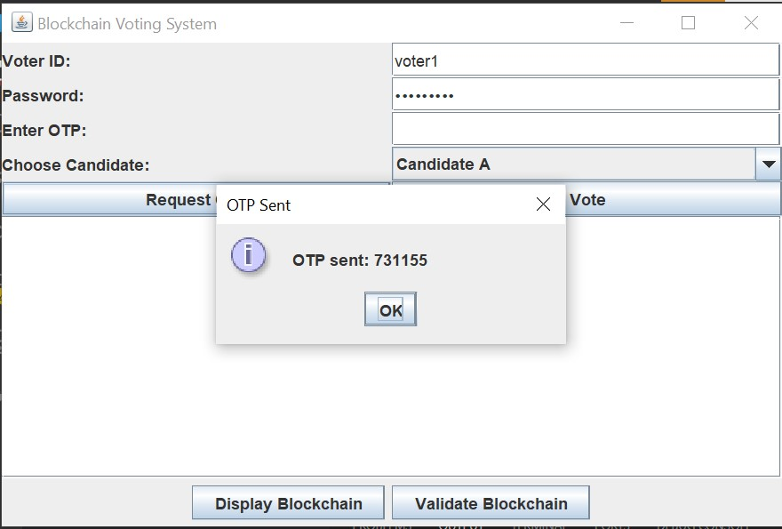

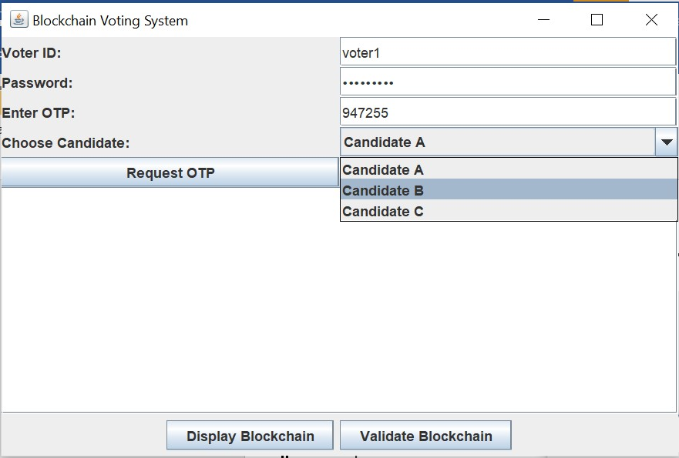

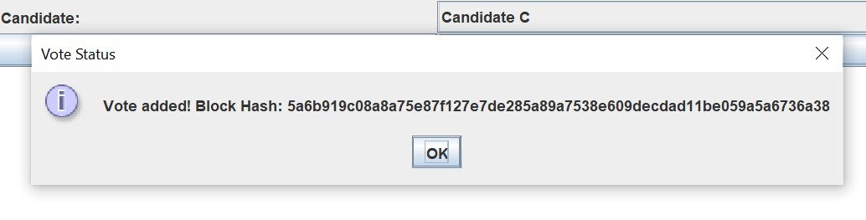

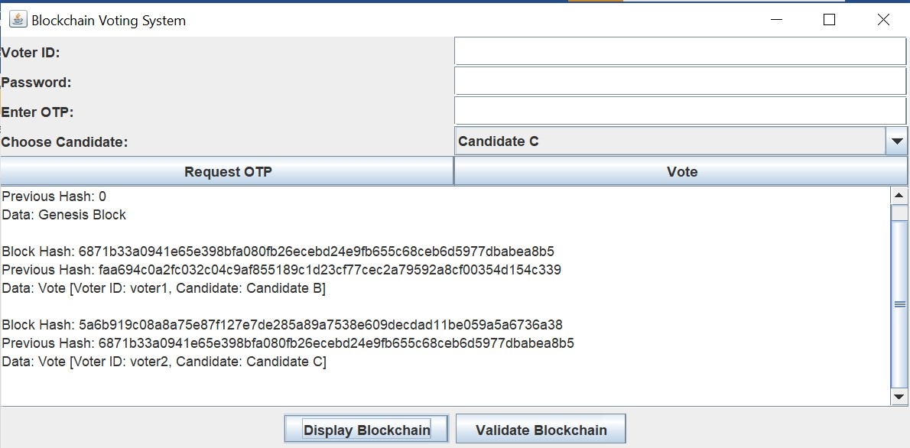

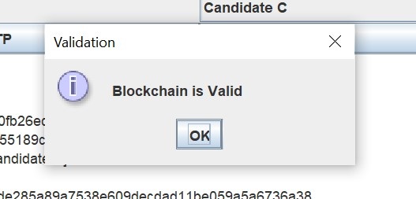

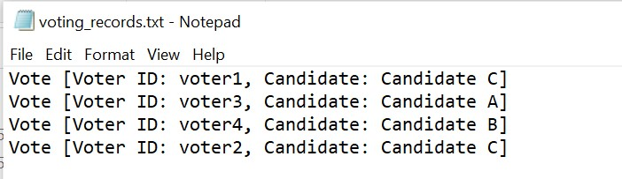

### CHAPTER 6 : CHALLENGES AND LIMITATIONS

1. **Technical Complexity :** 
   * **Integration Issues**: Difficulty in merging blockchain with existing voting systems.
   * **Scalability**: Challenges in handling high transaction volumes during elections.
2. **Security Concerns :** 
   * **Cybersecurity Threats**: Vulnerabilities in surrounding systems can lead to attacks.
   * **Smart Contract Vulnerabilities**: Bugs in smart contracts may compromise voting integrity.
3. **Voter Accessibility :** 
   * **Digital Divide**: Not all voters may have access to necessary technology.
   * **User Experience**: Designing an intuitive interface for all voters can be challenging.
4. **Privacy and Anonymity :** 
   * **Data Protection**: Maintaining voter anonymity while ensuring integrity is complex.
   * **Potential for Surveillance**: Transparency may inadvertently expose voting patterns.
5. **Legal and Regulatory Challenges :** 
   * **Compliance with Laws**: Adapting to existing electoral laws can be complicated.
   * **Jurisdictional Issues**: Varying regulations across regions complicate uniform implementation.
6. **Public Trust and Acceptance :** 
   * **Scepticism Towards Technology**: Voter reluctance to trust new systems is a barrier.
   * **Perception of Manipulation**: Concerns about technology misuse can undermine confidence.

### CHAPTER 7 : FUTURE PROSPECTS

1. **Increased Adoption :**
   * **Wider Implementation**: As technology matures and awareness grows, more jurisdictions may adopt blockchain voting systems to enhance transparency and security.
   * **Pilot Programs**: Continued pilot programs in various regions can provide valuable insights and build confidence in the technology.
2. **Technological Advancements :**
   * **Improved Scalability**: Ongoing innovations in blockchain technology may enhance scalability, enabling systems to handle larger voter bases efficiently.
   * **Interoperability Solutions**: Development of standardized protocols for interoperability between blockchain systems and traditional voting infrastructure could streamline implementation.
3. **Enhanced Security Features :**
   * **Advanced Cryptography**: Integration of more sophisticated cryptographic techniques can further protect voter identities and ensure data integrity.
   * **Decentralized Identity Management**: Improved solutions for voter identity verification can enhance security while maintaining privacy.
4. **Regulatory Frameworks :**
   * **Adaptation of Laws**: Governments and regulatory bodies may develop specific legal frameworks to govern blockchain voting, ensuring compliance with electoral laws.
   * **International Standards**: The establishment of global standards for blockchain voting can facilitate international cooperation and improve system credibility.

### CHAPTER 8 : CONCLUSION

Blockchain-based voting systems present a transformative opportunity to enhance the integrity, security, and transparency of electoral processes. By leveraging the decentralized and immutable nature of blockchain technology, these systems can address many challenges associated with traditional voting methods, such as fraud, lack of transparency, and voter disenfranchisement.

As we move towards an increasingly digital future, the potential for blockchain to streamline the voting process, increase public trust, and improve voter accessibility is significant. However, the successful implementation of these systems will depend on overcoming existing challenges, including technical complexities, security concerns, and the need for comprehensive regulatory frameworks.

Continued research, pilot projects, and collaborations among government agencies, technology providers, and civil society will be crucial in refining blockchain voting systems. Through education and engagement, stakeholders can foster public confidence and acceptance, paving the way for a more secure and democratic electoral process.

Ultimately, as technology evolves and more jurisdictions embrace innovation, blockchainbased voting systems hold the promise of revolutionizing how citizens participate in democracy, ensuring that every vote is counted and every voice is heard.

### CHAPTER 9 : REFERENCES

* **Books**
  + Nakamoto, S. (2008). **Bitcoin:** **A Peer-to-Peer Electronic Cash System**. Retrieved from bitcoin.org
  + Tapscott, D., & Tapscott, A. (2016). **Blockchain Revolution: How the Technology Behind Bitcoin Is Changing Money, Business, and the World.** Penguin Random House.
* **Research Papers**
  + Kshetri, N. (2016). **"Can Blockchain Strengthen the Global Supply Chain?"** The

Journal of Supply Chain Management, 52(4), 38-47. DOI: 10.1111/jscm.12145

* + Zhuang, Y., & Huang, J. (2018). **"Blockchain-based Voting System: A Survey"**.

IEEE Access, 6, 56376-56389. DOI: 10.1109/ACCESS.2018.2872639

* **Reports**
  + European Union Agency for Cybersecurity (ENISA). (2020). **Blockchain Applications in e-Government**. Retrieved from [enisa.europa.eu](https://www.enisa.europa.eu/publications/blockchain-applications-in-e-government)
  + National Institute of Standards and Technology (NIST). (2021). **Blockchain Technology Overview**. Retrieved from [nist.gov](https://nvlpubs.nist.gov/nistpubs/SpecialPublications/NIST.SP.800-211.pdf)
* **Online Articles and Blogs**
  + Catalini, C., & Gans, J. S. (2016). **"Some Simple Economics of the Blockchain"**. National Bureau of Economic Research. Retrieved from nber.org
  + **"The Future of Voting: The Promise of Blockchain"**. (2022). Harvard Business

Review. Retrieved from [hbr.org](https://hbr.org/2022/05/the-future-of-voting-the-promise-of-blockchain)

* **Case Studies**
  + **“Blockchain Voting: An Overview of Recent Initiatives”**. (2020). Council on Foreign Relations. Retrieved from cfr.org